$11.00 each
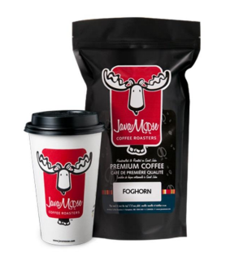

Options are:
½ lb bag of full beans
Or
½ lb of ground coffee
Or
Bag of 12 k-cups

Flavours include:
Foghorn – Our terrific dark roast. Rich flavour! Great aroma. Very INTENSE! Very SATISFYING
100% SWP Decaffeinated - Taste a decaf coffee that actually tastes like coffee. Chemical Free! & tasty!
Bay of Fundy Blend - A great Maritime coffee blended by the Bay of Fundy. Full bodied, aromatic and a little wild.
Cookies and Cream - A hazelnut cinnamon coffee flavour. One of our most popular coffees.
Vanilla Buttercream - Delicious vanilla bean flavour with farm fresh buttercream accents.
Egg Nog – Chestnuts and egg nog. Rich creamy flavour and rich rum accents in this truly classic festive treat.
Candy Cane – The unbelievable taste of creamy vanilla and that twist of mint. Just what Santa expects.
- Payment options: Cash or Cheque – payable to Royal Road Home and School Association
- If extra order forms are need, please print from school website
- Submit order form(s) along with all cash and cheques to the school by Friday October 28th
- Product should arrive the week of Dec 5th

Dear Parents and Guardians of Royal Road Elementary School students,
Last school year funds raised by the Home and School Association were used toward the purchase of 12 laptops for in-class use by students, Teacher Appreciation Day, and end of year student activities.
The Home and School Association is planning on various fundraisers throughout the school year to continue supporting student needs.
Based on past success this fundraiser is a partnership with a local company, Java Moose. Please find the order form attached.
We hope to continue partnering with local companies for our fundraising. More information to come in the new year.
Thank you for your continued support,
The Royal Road Home and School Association

